*#import all the required libraries*

**import** seaborn **as** sn

**import** pandas **as** pd

**import** numpy **as** np

**import** random **as** rd

**import** statistics **as** st

**import** matplotlib.pyplot **as** plt

**import** sklearn **as** sk

In [93]:

*#Get the data from local repository*

path **=** "/Users/aditya/Documents/My-files/Umkc/Spring/spring23/PDS/Assignment2/diabetes.csv"

df_raw **=** pd**.**read_csv(path)

In [94]:

*#show first 5 rows of dataset*

df_raw**.**head()

Out[94]:

|  | **Pregnancies** | **Glucose** | **BloodPressure** | **SkinThickness** | **Insulin** | **BMI** | **DiabetesPedigreeFunction** | **Age** | **Outcome** |
| --- | --- | --- | --- | --- | --- | --- | --- | --- | --- |
| 0 | 6 | 148 | 72 | 35 | 0 | 33.6 | 0.627 | 50 | 1 |
| 1 | 1 | 85 | 66 | 29 | 0 | 26.6 | 0.351 | 31 | 0 |
| 2 | 8 | 183 | 64 | 0 | 0 | 23.3 | 0.672 | 32 | 1 |
| 3 | 1 | 89 | 66 | 23 | 94 | 28.1 | 0.167 | 21 | 0 |
| 4 | 0 | 137 | 40 | 35 | 168 | 43.1 | 2.288 | 33 | 1 |

print("Number of Rows: {}\nNumber of Columns: {}"**.**format(df_raw**.**shape[0], df_raw**.**shape[1]))

Number of Rows: 768

Number of Columns: 9

*#let us check if we have any null values in the data*

df_raw**.**isnull()**.**sum()

Pregnancies 0

Glucose 0

BloodPressure 0

SkinThickness 0

Insulin 0

BMI 0

DiabetesPedigreeFunction 0

Age 0

Outcome 0

dtype: int64

*#The data looks clean, so we can use the same raw data for our future analysis*

df_raw**.**to_csv('/Users/aditya/Documents/My-files/Umkc/Spring/spring23/PDS/Project/Diabetes/CleanData/clean_data.csv')

*##Let us now create a sample from the polulation*

*#we make use of random state to reproduce the result*

*#seed = random.seed(10)*

df_getsample_frompopulation**=** df_raw**.**sample(n**=** 25, random_state**=** 42)

*#fetch the first five rows of sample*

df_getsample_frompopulation**.**head()

Pregnancies Glucose BloodPressure SkinThickness Insulin BMI DiabetesPedigreeFunction Age Outcome

668 6 98 58 33 190 34.0 0.430 43 0

324 2 112 75 32 0 35.7 0.148 21 0

624 2 108 64 0 0 30.8 0.158 21 0

690 8 107 80 0 0 24.6 0.856 34 0

473 7 136 90 0 0 29.9 0.210 50 0

*# number of rows are 25 in the smaple*

print("Number of Rows: {}\nNumber of Columns: {}"**.**format(df_getsample_frompopulation**.**shape[0], df_raw**.**shape[1]))

Number of Rows: 25

Number of Columns: 9

In [99]:

*#find the mean Glucose of the sample on importing statistics package*

mean_glucose_sample **=** st**.**mean(df_getsample_frompopulation**.**loc[:,"Glucose"])

print(mean_glucose_sample)

116.64

In [101]:

*#find the max Glucose of the sample*

max_glucose_sample **=** max(df_getsample_frompopulation**.**loc[:,"Glucose"])

print(max_glucose_sample)

183

In [102]:

*#find the mean Glucose of the population*

mean_glucose_population **=** st**.**mean(df_raw**.**loc[:,"Glucose"])

print(mean_glucose_population)

120.89453125

*#find the max Glucose of the population*

max_glucose_population **=** max(df_raw**.**loc[:,"Glucose"])

print(max_glucose_population)

199

In [153]:

*# let us create a dictonary which stores the mean values of sample and population*

*# which helps in plotting the graphs*

**class** mean_dictionary(dict):

**def** __init__(self):

self **=** dict()

**def** add(self, key, value):

self[key] **=** value

*# Main Function*

dict_mean **=** mean_dictionary()

dict_mean**.**add('mean_sample', mean_glucose_sample)

dict_mean**.**add('mean_population', mean_glucose_population)

print(dict_mean)

*## Saving the results into results folder*

result_save **=** open("/Users/aditya/Documents/My-files/Umkc/Spring/spring23/PDS/Project/Diabetes/Results/A/dict_mean.txt","w")

*# write file*

result_save**.**write(str(dict_mean))

*# close file*

result_save**.**close()

{'mean_sample': 116.64, 'mean_population': 120.89453125}

In [154]:

*# let us create a dictonary which stores the max values of sample and population*

*# which helps in plotting the graphs*

**class** max_dictionary(dict):

**def** __init__(self):

self **=** dict()

**def** add(self, key, value):

self[key] **=** value

*# Main Function*

dict_max **=** max_dictionary()

dict_max**.**add('max_sample', max_glucose_sample)

dict_max**.**add('max_population', max_glucose_population)

print(dict_max)

*## Saving the results into results folder*

result_save **=** open("/Users/aditya/Documents/My-files/Umkc/Spring/spring23/PDS/Project/Diabetes/Results/A/dict_max.txt","w")

*# write file*

result_save**.**write(str(dict_max))

*# close file*

result_save**.**close()

{'max_sample': 183, 'max_population': 199}

*#creating the bar graph for sample vs population mean*

*# the graph clearly shows that mean_population is slightly higher on copmaring with mean_sample*

mean_values **=** list(dict_mean**.**keys())

values **=** list(dict_mean**.**values())

fig **=** plt**.**figure(figsize **=** (4, 5))

*# creating the bar plot*

plt**.**bar(mean_values, values, color **=**'blue',

width **=** 0.4)

plt**.**xlabel("sample vs population mean")

plt**.**ylabel("mean values")

plt**.**title("mean measurement")

plt**.**savefig("/Users/aditya/Documents/My-files/Umkc/Spring/spring23/PDS/Project/Diabetes/Results/A/mean_barimage.jpeg")

plt**.**show()

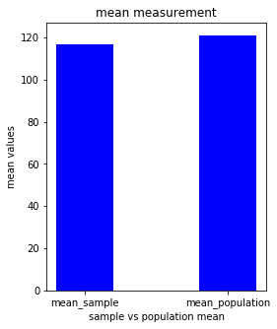

*#creating the pie graph for sample vs population mean*

*# the graph clearly shows that mean_population is slightly higher on comparing with mean_sample*

plt**.**pie(values, labels **=** mean_values, autopct**=**'%1.1f%%', shadow**=True**, startangle**=**90)

plt**.**savefig("/Users/aditya/Documents/My-files/Umkc/Spring/spring23/PDS/Project/Diabetes/Results/A/mean_pieimage.jpeg")

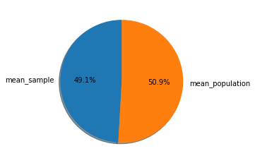

*#creating the bar graph for sample vs population max*

*#the graph clearly shows that max_population is higher on comparing with max_sample*

max_values **=** list(dict_max**.**keys())

values **=** list(dict_max**.**values())

fig **=** plt**.**figure(figsize **=** (4, 5))

*# creating the bar plot*

plt**.**bar(max_values, values, color **=**'red',

width **=** 0.4)

plt**.**xlabel("sample vs population")

plt**.**ylabel("highest values")

plt**.**title("highest value measurement")

plt**.**savefig("/Users/aditya/Documents/My-files/Umkc/Spring/spring23/PDS/Project/Diabetes/Results/A/max_barimage.jpeg")

plt**.**show()

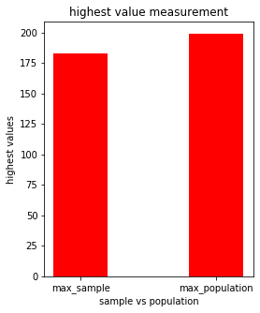

In [161]:

*#creating the pie graph for sample vs population max*

*#the graph clearly shows that max_population is higher on comparing with max_sample*

plt**.**pie(values, labels **=** max_values , autopct**=**'%1.1f%%', shadow**=True**, startangle**=**90)

plt**.**savefig("/Users/aditya/Documents/My-files/Umkc/Spring/spring23/PDS/Project/Diabetes/Results/A/max_pieimage.jpeg")

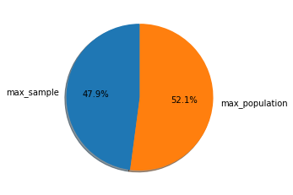

*#let us now find the 98th percentile of sample data*

sample_percentile **=** np**.**percentile(df_getsample_frompopulation**.**loc[:,"BMI"], 98)

print(sample_percentile)

40.248

In [109]:

*#find the 98th percentile of population data*

population_percentile **=** np**.**percentile(df_raw**.**loc[:,"BMI"], 98)

print(population_percentile)

47.52599999999996

In [162]:

*# let us create a dictonary which stores the percentile values of sample and population*

*# which helps in plotting the graphs*

**class** percentile_dictionary(dict):

**def** __init__(self):

self **=** dict()

**def** add(self, key, value):

self[key] **=** value

*# Main Function*

dict_percentile **=** percentile_dictionary()

dict_percentile**.**add('sample_percentile', sample_percentile)

dict_percentile**.**add('population_percentile', population_percentile)

print(dict_percentile)

*## Saving the results into results folder*

result_save **=** open("/Users/aditya/Documents/My-files/Umkc/Spring/spring23/PDS/Project/Diabetes/Results/B/dict_percentile.txt","w")

*# write file*

result_save**.**write(str(dict_percentile))

*# close file*

result_save**.**close()

{'sample_percentile': 40.248, 'population_percentile': 47.52599999999996}

In [163]:

*#creating the bar graph for sample vs population percentile*

*#the graph clearly shows that population_percentile is higher on comparing with sample_percentile*

percentile_values **=** list(dict_percentile**.**keys())

values **=** list(dict_percentile**.**values())

fig **=** plt**.**figure(figsize **=** (4, 5))

*# creating the bar plot*

plt**.**bar(percentile_values, values, color **=**'green',

width **=** 0.4)

plt**.**xlabel("sample vs population")

plt**.**ylabel("percentile values")

plt**.**title("percentile value measurement")

plt**.**savefig("/Users/aditya/Documents/My-files/Umkc/Spring/spring23/PDS/Project/Diabetes/Results/B/percentile_barimage.jpeg")

plt**.**show()

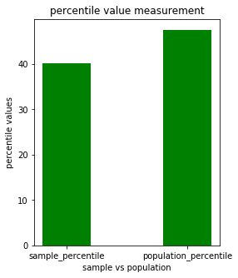

In [164]:

*#creating the pie graph for sample vs population percentile*

*#the graph clearly shows that population_percentile is higher on comparing with sample_percentile*

plt**.**pie(values, labels **=** percentile_values , autopct**=**'%1.1f%%', shadow**=True**, startangle**=**90)

plt**.**savefig("/Users/aditya/Documents/My-files/Umkc/Spring/spring23/PDS/Project/Diabetes/Results/B/percentile_pieimage.jpeg")

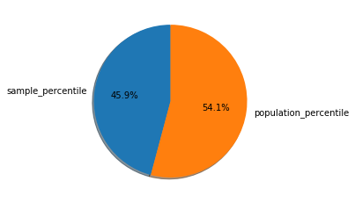

*#Using bootstrap (replace= True), created 500 samples (of 150 observation each) from the population(raw_data)*

boot **=** sk**.**utils**.**resample(df_raw, replace**=True**, n_samples**=**500, random_state**=**150)

print(boot)

Pregnancies Glucose BloodPressure SkinThickness Insulin BMI \

228 4 197 70 39 744 36.7

442 4 117 64 27 120 33.2

507 1 130 60 23 170 28.6

25 10 125 70 26 115 31.1

496 5 110 68 0 0 26.0

.. ... ... ... ... ... ...

732 2 174 88 37 120 44.5

514 3 99 54 19 86 25.6

750 4 136 70 0 0 31.2

364 4 147 74 25 293 34.9

485 0 135 68 42 250 42.3

DiabetesPedigreeFunction Age Outcome

228 2.329 31 0

442 0.230 24 0

507 0.692 21 0

25 0.205 41 1

496 0.292 30 0

.. ... ... ...

732 0.646 24 1

514 0.154 24 0

750 1.182 22 1

364 0.385 30 0

485 0.365 24 1

[500 rows x 9 columns]

In [113]:

*#find the mean BMI of the bootstrapsample*

mean_bootBMI **=** mean(boot**.**loc[:,"BMI"])

print(mean_bootBMI)

31.8188

In [114]:

*#find the std BMI of the bootstrapsample*

std_bootBMI **=** st**.**stdev(boot**.**loc[:,"BMI"])

print(std_bootBMI)

8.058660594736716

In [115]:

*#find the percentile BMI of the bootstrapsample*

percentile_bootBMI **=** np**.**percentile(boot**.**loc[:,"BMI"], 98)

print(percentile_bootBMI)

46.50599999999999

In [116]:

*#find the mean BMI of the population*

mean_rawBMI **=** mean(df_raw**.**loc[:,"BMI"])

print(mean_rawBMI)

31.992578125

In [117]:

*#find the std BMI of the population*

std_rawBMI **=** st**.**stdev(df_raw**.**loc[:,"BMI"])

print(std_rawBMI)

7.884160320375446

In [119]:

*#find the percentile BMI of the population*

percentile_rawBMI **=** np**.**percentile(df_raw**.**loc[:,"BMI"], 98)

print(percentile_rawBMI)

47.52599999999996

*# let us create a dictonary which stores the mean values of sample and population*

*# which helps in plotting the graphs*

**class** Bootmean_dictionary(dict):

**def** __init__(self):

self **=** dict()

**def** add(self, key, value):

self[key] **=** value

*# Main Function*

dict_Bootmean **=** Bootmean_dictionary()

dict_Bootmean**.**add('mean_Bootsample', mean_bootBMI)

dict_Bootmean**.**add('mean_population', mean_rawBMI)

print(dict_Bootmean)

*## Saving the results into results folder*

result_save **=** open("/Users/aditya/Documents/My-files/Umkc/Spring/spring23/PDS/Project/Diabetes/Results/C/dict_Bootmean.txt","w")

*# write file*

result_save**.**write(str(dict_Bootmean))

*# close file*

result_save**.**close()

{'mean_Bootsample': 31.8188, 'mean_population': 31.992578125}

*#creating the bar graph for sample vs population mean*

*#the graph clearly shows that population is higher on comparing with sample*

Bootmean_values **=** list(dict_Bootmean**.**keys())

values **=** list(dict_Bootmean**.**values())

fig **=** plt**.**figure(figsize **=** (4, 5))

*# creating the bar plot*

plt**.**bar(Bootmean_values, values, color **=**'orange',

width **=** 0.4)

plt**.**xlabel("Bootstrapsample vs population")

plt**.**ylabel("mean values")

plt**.**title("mean value measurement")

plt**.**savefig("/Users/aditya/Documents/My-files/Umkc/Spring/spring23/PDS/Project/Diabetes/Results/C/bootmean_barimage.jpeg")

plt**.**show()

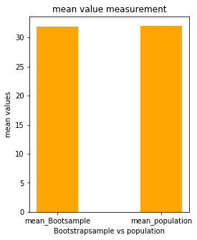

*#creating the pie graph for sample vs population mean*

*#the graph clearly shows that population is higher on comparing with sample*

plt**.**pie(values, labels **=** Bootmean_values, autopct**=**'%1.1f%%', shadow**=True**, startangle**=**90)

plt**.**savefig("/Users/aditya/Documents/My-files/Umkc/Spring/spring23/PDS/Project/Diabetes/Results/C/bootmean_pieimage.jpeg")

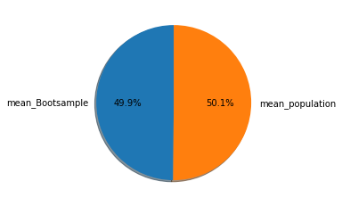

In [168]:

*# let us create a dictonary which stores the std values of sample and population*

*# which helps in plotting the graphs*

**class** Bootstd_dictionary(dict):

**def** __init__(self):

self **=** dict()

**def** add(self, key, value):

self[key] **=** value

*# Main Function*

dict_Bootstd **=** Bootstd_dictionary()

dict_Bootstd**.**add('std_Bootsample', std_bootBMI)

dict_Bootstd**.**add('std_population', std_rawBMI)

print(dict_Bootstd)

*## Saving the results into results folder*

result_save **=** open("/Users/aditya/Documents/My-files/Umkc/Spring/spring23/PDS/Project/Diabetes/Results/C/dict_Bootstd.txt","w")

*# write file*

result_save**.**write(str(dict_Bootstd))

*# close file*

result_save**.**close()

{'std_Bootsample': 8.058660594736716, 'std_population': 7.884160320375446}

In [170]:

*#creating the bar graph for sample vs population std*

*#the graph clearly shows that population is slightly higher on comparing with sample*

Bootstd_values **=** list(dict_Bootstd**.**keys())

values **=** list(dict_Bootstd**.**values())

fig **=** plt**.**figure(figsize **=** (4, 5))

*# creating the bar plot*

plt**.**bar(Bootstd_values, values, color **=**'silver',

width **=** 0.4)

plt**.**xlabel("Bootstrap sample vs population")

plt**.**ylabel("SD values")

plt**.**title("SD value measurement")

plt**.**savefig("/Users/aditya/Documents/My-files/Umkc/Spring/spring23/PDS/Project/Diabetes/Results/C/bootstd_barimage.jpeg")

plt**.**show()

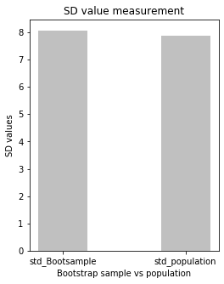

In [171]:

*#creating the pie graph for sample vs population std*

*#the graph clearly shows that population is slightly higher on comparing with sample*

plt**.**pie(values, labels **=** Bootstd_values , autopct**=**'%1.1f%%', shadow**=True**, startangle**=**90)

plt**.**savefig("/Users/aditya/Documents/My-files/Umkc/Spring/spring23/PDS/Project/Diabetes/Results/C/bootstd_pieimage.jpeg")

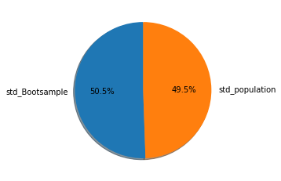

*# let us create a dictonary which stores the percentile values of sample and population*

*# which helps in plotting the graphs*

**class** Bootpercentile_dictionary(dict):

**def** __init__(self):

self **=** dict()

**def** add(self, key, value):

self[key] **=** value

*# Main Function*

dict_Bootpercentile **=** Bootpercentile_dictionary()

dict_Bootpercentile**.**add('percentile_Bootsample', percentile_bootBMI)

dict_Bootpercentile**.**add('percentile_population', percentile_rawBMI)

print(dict_Bootpercentile)

*## Saving the results into results folder*

result_save **=** open("/Users/aditya/Documents/My-files/Umkc/Spring/spring23/PDS/Project/Diabetes/Results/C/dict_Bootpercentile.txt","w")

*# write file*

result_save**.**write(str(dict_Bootstd))

*# close file*

result_save**.**close()

{'percentile_Bootsample': 46.50599999999999, 'percentile_population': 47.52599999999996}

*#creating the bar graph for sample vs population percentile*

*#the graph clearly shows that population is slightly higher on comparing with sample*

Bootpercentile_values **=** list(dict_Bootpercentile**.**keys())

values **=** list(dict_Bootpercentile**.**values())

fig **=** plt**.**figure(figsize **=** (4, 5))

*# creating the bar plot*

plt**.**bar(Bootpercentile_values, values, color **=**'purple',

width **=** 0.4)

plt**.**xlabel("Bootstrap sample vs population")

plt**.**ylabel("Percentile values")

plt**.**title("percentile value measurement")

plt**.**savefig("/Users/aditya/Documents/My-files/Umkc/Spring/spring23/PDS/Project/Diabetes/Results/C/bootpercentile_barimage.jpeg")

plt**.**show()

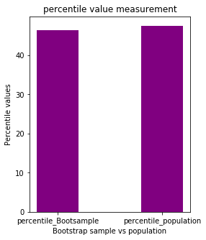

In [174]:

*#creating the bar graph for sample vs population percentile*

*#the graph clearly shows that population is slightly higher on comparing with sample*

plt**.**pie(values, labels **=** Bootpercentile_values, autopct**=**'%1.1f%%', shadow**=True**, startangle**=**90)

plt**.**savefig("/Users/aditya/Documents/My-files/Umkc/Spring/spring23/PDS/Project/Diabetes/Results/C/bootpercentile_barimage.jpeg")

